Invisible Man Reading Schedule (Fall 2017)
AP Literature & Composition/Mrs. Decker

Assigned Reading: | Due Date
Introductory Articles (read & annotate) | Tuesday, September 12
Prologue to Chapter 2 (pp. 1-70) | Thursday, September 14
Chapters 3-4 (pp. 71-108) | Monday, September 18
Chapters 5-8 (pp. 109-171) | Thursday, September 21
Chapters 9-10 (pp. 172-230) | Tuesday, September 26
Chapters 11-15 (pp. 231-332) [6 days for reading] | Monday, October 2
Chapters 16-17 (pp. 333-382) | Thursday, October 5
Chapters 18-20 (pp. 383-444) | Tuesday, October 10
Chapters 21-23 (pp. 445-512) | Thursday, October 12
Chapters 24-Epilogue (pp. 513-581) | Tuesday, October 17
Final novel assessment/discussion | Thursday, October 19
Culminating Class Project | Details to be provided

Short essays, close-reading activities, discussions, quizzes and group activities will be part of this unit.

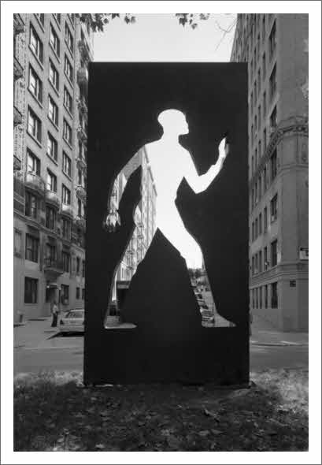

Invisible Man: A Memorial to Ralph Ellison
Sculpture. Elizabeth Catlett, 2003.

