Macbeth Motif Project Due Date: ________________________
English IV/Mrs. Decker

For this assignment, you will select one of the following motifs (an object or idea that repeats itself in literature) from Macbeth.

Blood Ambition Hands
Sleep Weather Prophecy
Hallucinations Nature (incl. human) Violence
Manhood Darkness and Light Babies and Children

You will create a VISUAL DISPLAY to illustrate your motif. You must include:
- The word(s) - create word art out of your selected motif
- Denotation and Connotation:
  - Denotation: the dictionary definition of the word(s)
  - Connotation: what the word(s) implies or the emotional attachment(s) we associate with the word(s) - you should have several
- A list of at least 5 words that are associated with your word (Example: If your motif is EYE, your words could be: sight, see, lid, pupil, color, etc.)
- A brief paragraph explaining Shakespeare’s use of the motif throughout the play, how it affects characters, etc.
- At least four (4) references to the motif throughout all five acts of the play (4 quotes including act, scene, and line numbers) AND an explanation for each quote (what is happening in the play at the time the quote is spoken?)
- At least two images that relate to the word and its use in the play. Create colorful drawings that reflect your motif’s use in the play. No pencil illustrations.
- Clearly label your project with the play’s title. Neatness counts. Be creative and use color.
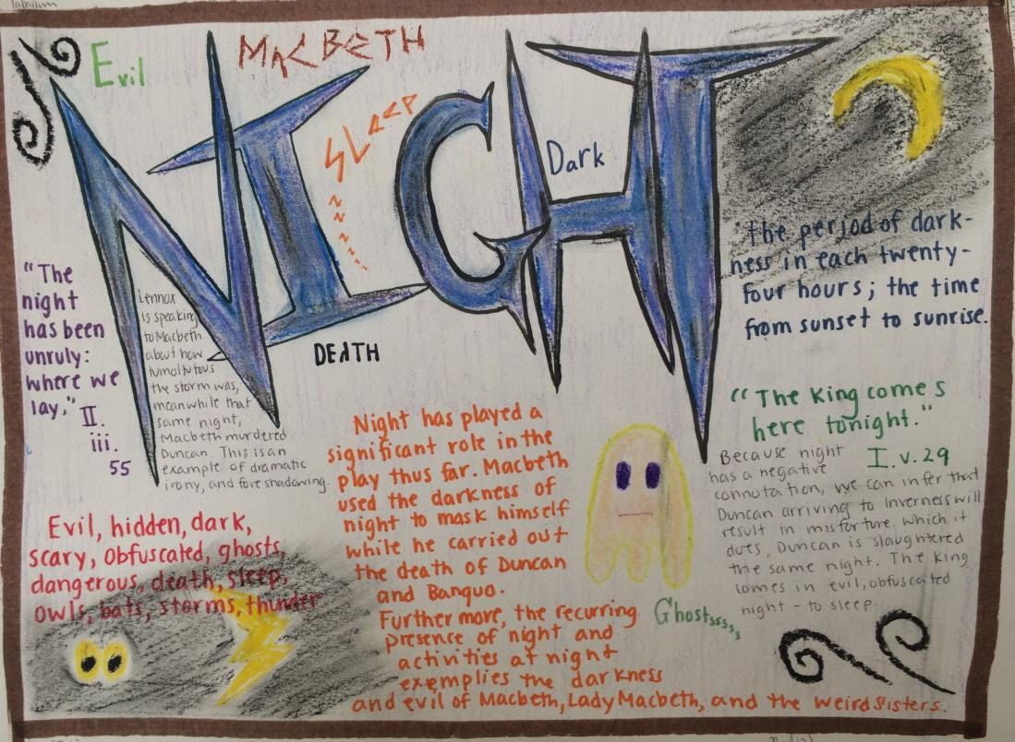
- You will present your illustration to the class. (Failure to present = maximum grade of 69)

All work must be drawn by hand; no computer print-outs or graphics are allowed. You must use unlined paper. Your work must be colorful and visually appealing; no basic pen/pencil drawings will be accepted.

Here is an example:
Notice the good use of illustrations with the quotations. Each quotation has an explanation. The word is centered and focused and makes good use of word art.

Macbeth Motif Project Rubric Name________________________________
English IV/Mrs. Decker

Word: the selected motif/word is clearly displayed | _____/8
Denotation: the dictionary definition of the word is displayed  &  Connotation: a description of the word’s implication/emotional attachment is displayed | _____/8
5 Words: five words associated with the chosen word are displayed | _____/8
Brief Paragraph: a brief paragraph explaining Shakespeare’s use of the motif throughout the play is provided | _____/7
4 Quotes: four quotes selected from the play are displayed; an explanation for each is provided | _____/10
2 Images: two images that reflect the selected motif’s use in the play are displayed | _____/8
Play title: the play’s title is clearly displayed | _____/5
Grammar & Mechanics: are properly used throughout | _____/5
Creativity & Effort: project is neat; creativity and effort from the artist are apparent (good use of color, illustrations are neat and effective, project is visually appealing, etc.) | _____/10
Presentation: student presents project with enthusiasm and confidence; all parts of project are clearly explained | ____/31

Total ________/100
Teacher Comments:

