Study Guide
for

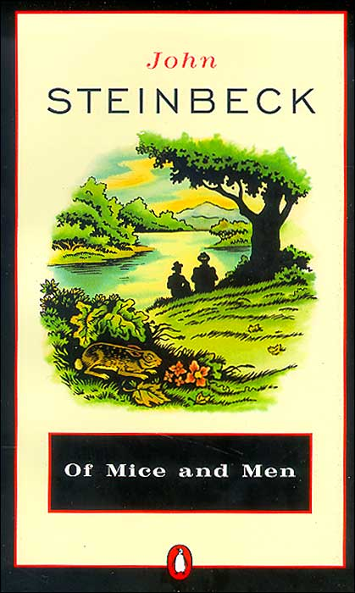

Name: ________________________

Of Mice and Men READING QUESTIONS

Chapter 1
1. Identify and give a physical description of Lennie and George.
2. What is George's first complaint to Lennie?
3. What trouble did George and Lennie have in Weed?
4. What is in Lennie's pocket? Why does he have it?
5. George bursts into a long speech about what he could do if he were alone. What could he do?

6. Lennie offers to go away and live in a cave. What is George's response?

7. Why are George and Lennie different from the other "guys like us that work on ranches"?

8. What are George and Lennie going to do someday?
9. What two things does George want Lennie to remember?
10. Why does George want to camp overnight instead of going another quarter of a mile to the ranch?

Chapter 2
1. What does George answer when the boss asks what he is trying to put over?

2. Identify and describe Curley.
3. The swamper said, "Seems like Curley ain't givin' nobody a chance." Explain.

4. What advice does George give Lennie after Curley and the swamper leave?

5. Identify Slim and Carlson.
6. What does Slim have that Lennie wants?

Chapter 3
1. Slim and George have a long conversation. Slim says it's funny how George and Lennie go around together. What is George's answer?

2. Identify Candy.
3. What does Carlson do with his Luger? Why?
4. What card game does George play?
5. Describe Curley's wife. What's the problem about her?
6. What will Lennie's job be when he and George get their land?
7. What does Candy want when he hears about George's and Lennie's plans? What is he willing to contribute?

8. Why does Curley fight with Lennie? What happens?

Chapter 4
1. Identify Crooks.
2. Lennie tells Crooks about the land. What is his reply at first?
3. What does Crooks want when he believes there might really be land?

4. Why does Curley's wife come to the barn?
5. Why does Crooks change his mind after Curley's wife left?

Chapter 5
1. What happens to Lennie's puppy? What is his reaction?
2. Why does Curley's wife come to see Lennie?
3. What does she tell Lennie?
4. What happens to Curley's wife?
5. What is George's reaction when he finds out about Curley's wife?

6. What is Curley's reaction when he finds out about his wife?

Chapter 6
1. How and why does George do what he does?
2. Who is the only one who really understands what George does?

Themes, Motifs, Symbols and Names from Of Mice and Men

THEMES
(the fundamental and often universal ideas explored in a literary work)
Friendship

The American Dream

Motifs
(a recurring structure that supports a theme)
The corrupting power of women

Loneliness and Companionship

Strength and Weakness

SYMBOLS
(objects, characters, figures, or colors used to represent abstract ideas or concepts)
George’s and Lennie’s Farm

Lennie’s puppy

Candy’s dog

NAMES
(consider the significance)
Lennie Small

Curley’s wife vs. Susy

Aunt Clara

