One-Word Project
For this assignment, you are to choose one word that is a common occurrence in the sermon “Sinners in the Hands of an Angry God.” You can pick from the list below, or choose your own (please allow me to approve the alternate word):

Wrath Dreadful
Pit Nothing
Sin Misery
Fire (or burning) Hands

Your finished project must include:
- Word (create word art out of your selected word; make it the focal point of your project)
- Denotation and Connotation:
  - Denotation = Dictionary definition of the word
  - Connotation = What is implied by the word, the emotional attachment we associate with the word (you should have several)
- A list of at least 5 words that are associated with your word (Example: If my word is EYE, my words could be: sight, see, lid, pupil, color, etc.)
- Description of how this word relates to the excerpt of the sermon in at least two sentences.
- At least three quotes from the sermon that support how this word relates to the sermon purpose, with an explanation for each.
- At least two images that relate to the word and its use in the sermon. Create colored drawings that reflect your word’s use in the sermon. No pencil illustrations.
- Clearly label your project with the sermon’s title. Neatness counts. Be creative and use color.
Note: All work must be hand-drawn; no basic pen/pencil drawings and no computer print-outs/graphics are allowed. Do not use notebook paper.

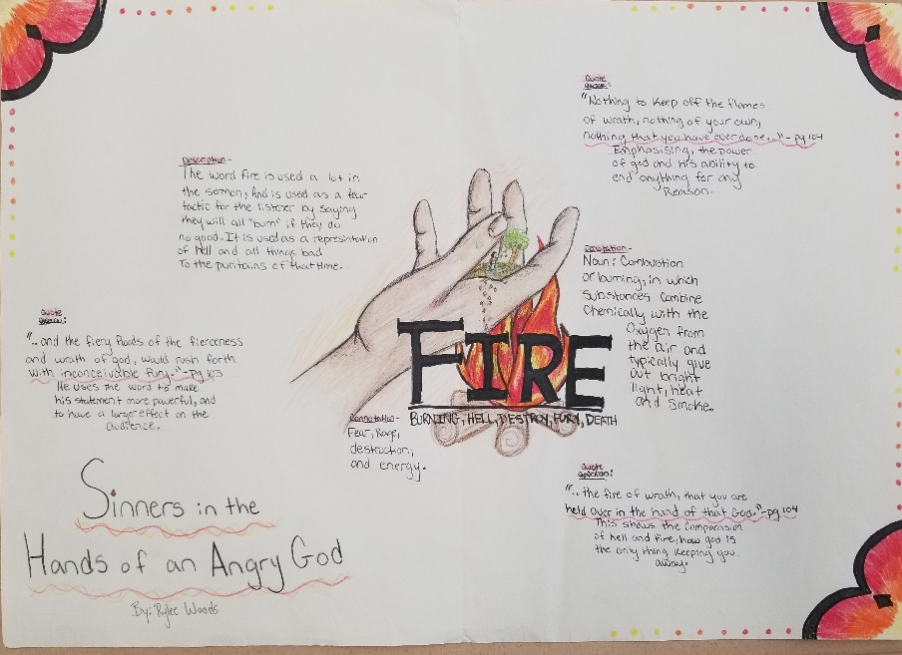
Example: Notice the good use of illustrations. Each quotation has an explanation. The selected word is centered and focused, the sermon title is clearly displayed, etc.
“Sinners…” One-Word Project Name________________________________
English III/Honors English III

Word: The selected word is clearly displayed on the project. | 20 pts
Denotation & Connotation: The dictionary definition should be present, as well as, a description of the emotional attachment that is implied by the word. | 10 pts
5 Words: Five words that are associated with the chosen words are displayed on the project along with a description of how the chosen word relates to the sermon. | 20pts
3 Quotes: Three quotes selected from the sermon are displayed on the project along with an explanation for each. | 10pts
2 Images: Two images are displayed on the project that reflect the selected word’s use in the sermon. | 10pts
Sermon title: The sermon’s title is clearly displayed on the project. | 10pts
Grammar: Proper use of grammar with no spelling errors. | 10pts
Creativity & Effort: The project is neat. Creativity and effort from the artist is apparent. Ex: use of color, illustrations are neat and effective. | 10pts

Total _____/100

“Sinners…” One-Word Project Name________________________________
English III/Honors English III

Word: The selected word is displayed on the project. | 20 pts
Denotation & Connotation: The dictionary definition should be present, as well as, a description of the emotional attachment that is implied by the word. | 10 pts
5 Words: The five words that are associated with the chosen words are displayed on the project along with a description of how the chosen word relates to the sermon. | 20pts
3 Quotes: The three quotes selected from the sermon are displayed on the project along with an explanation for each. | 10pts
2 Images: Two images are displayed on the project that reflect the selected word’s use in the sermon. | 10pts
Sermon title: The sermon’s title is clearly displayed on the project. | 10pts
Grammar: Proper use of grammar with no spelling errors. | 10pts
Creativity & Effort: The project is neat. Creativity and effort from the artist is apparent. Ex: use of color, illustrations are neat and effective. | 10pts

Total _____/100

